**The Social Network**

This is a web portal developed using php, bootstrap, html and mySQL. This integrates various social networking platforms such as Facebook, Instagram, Twitter etc.

Any user can stay updated about all the supported social networking platforms using this single application “TheSocialNetwork”

This app has very easy to understand and use GUI.

This uses APIs provided by various social networking platforms such as Graph API by facebook and Instagram.

The Home page

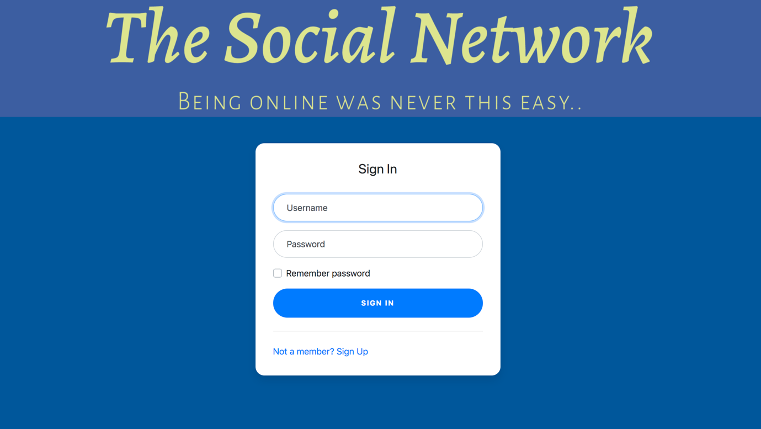

The User registration form

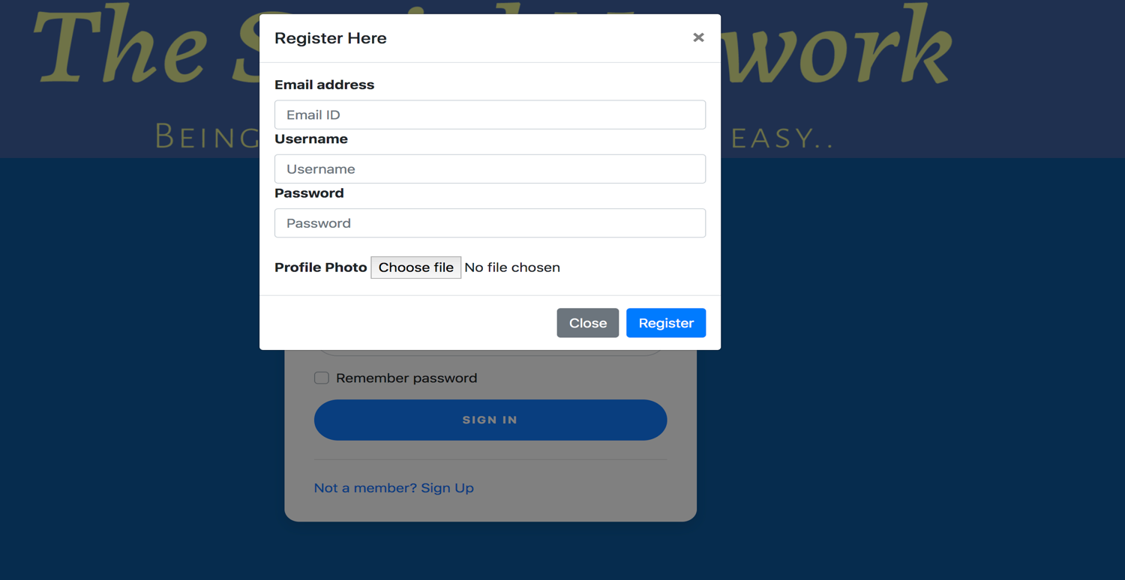

The Welcome page after Login

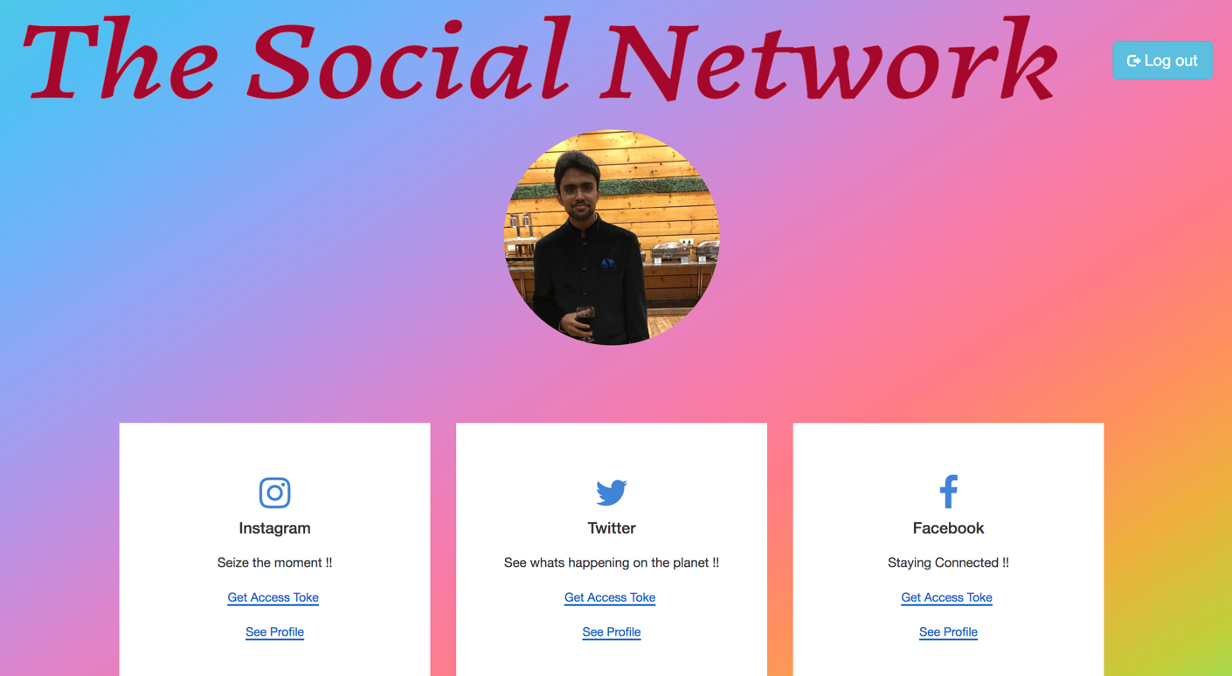

The Facebook Profile

